DRAFT FOR REVIEW

Corporate responsibility, voluntary agreements and competition law
A ‘How to’ Guide

September 2010

Acknowledgments
To follow

Contents
1.0 Executive Summary 4
2.0 Concepts and context 5
2.1 What are Corporate Responsibility and Sustainability? 5
2.2 The regulatory spectrum 5
2.3 Voluntary agreements and standards 6
2.4 Competition law and voluntary agreements 10
3.0 Compliance 17
3.1 Information exchange 17
3.2 ‘Pass-on’ of a fair share of benefits to consumers 18
3.3 Trade associations, self-regulation bodies and membership organisations 18
3.4 Corporate compliance 22
3.5 The OFT’s Short-Form Opinions (SFO) procedure 23
4.0 Crafting effective voluntary agreements and standards 24
4.1 Good practice criteria in establishing new schemes 24
4.2 Understanding market impacts 25
4.3 The OFT self-regulatory scheme assessment model 28
4.4 Voluntary agreements that go beyond national and EU borders 29
5.0 Co-regulation and self-regulation in practice 31
6.0 Challenges and opportunities 32
6.1 Mapping the landscape and engaging stakeholders: RaceToTheTop.org 32
6.2 Improving co-/self-regulation guidance and tools 32
6.3 Sustainable consumption 37
6.4 Social concerns 39
Glossary 40
Bibliography 41
Appendices 42
Appendix 1 - Corporate Competition Law compliance policies and guidelines best practice examples 42
Appendix 2 - Model Competition law compliance policy for trade associations 43
Appendix 3 - ISEAL Codes of Good Practice 49
Appendix 4 - Competition test decision flow chart 51
Appendix 5 - Use of an independent third party or trustee 52

1.0 Executive Summary
This ‘How to’ Guide was conceived to remove some of the uncertainties that have existed in the business community over the past decade as to when and how companies can collaborate and co-/self-regulate through voluntary agreements and standards. These concerns have been raised by organisations from Business in the Community to the British Hospitality Association, and appear to have sometimes prevented, or at least slowed, development of new responsible business practices, particularly in complex ‘non-win-win’ situations.
Despite the risks that the onus for competition law compliance shifting back onto business in the late nineties presented, many successful voluntary agreements and standards with significant impact, often beyond UK borders, have been established (see section 5). These are set to increase further with the encouragement of the UK’s Coalition Government, which has coined the term ‘Responsibility Deals’ for a new generation of self-/co-regulatory agreements.
The guide introduces the basics of Competition Law and Voluntary Agreements in section 2. In researching this guide we have drawn three key conclusions for businesses:
- Manage your company’s competition law compliance processes and potential risks with care and ensure that trade associations (or similar) of which you are a member are building their compliance capabilities – for more information see section 3;
- Participate actively in the design and roll-out of voluntary agreements relevant to your sector drawing upon appropriate advice from the ISEAL Alliance, Business in the Community, the Trade Association Forum, law firms and other advisors. For more information see section 4;
- Whilst this guide emphasises what is already possible, further improvements to competition law/ guidance – and their application – must be encouraged so that social and environmental (public policy) factors are given due weight in decisions by competition authorities in the UK and around the world. For more information see section 6.
The guide is written to assist professionals working in corporate responsibility, trade associations, competition law, investment and government navigate international competition law and encourage more voluntary agreements and standards between companies where there are demonstrable public benefits. Throughout the guide, we have highlighted in blue best practice and top tips.

2.0 Concepts and context

2.1 What are Corporate Responsibility and Sustainability?

Corporate Responsibility has been defined by Business in the Community as ‘the management of a company’s positive impact on society and the environment through its operations, products or services and through its interaction with key stakeholders’. The term has emerged in preference to Corporate Social Responsibility, which appeared to promote the social at the expense of the environmental dimension. Other related terms include Corporate Sustainability, Corporate Citizenship and Corporate Governance. They emphasise different aspects of responsible business management.

In recent years there has been growing use of the term Corporate Sustainability instead or as well as Corporate Responsibility as businesses realise the need to take a longer-term view. This also reflects environmental and social factors increasingly being integrated with businesses’ consideration of financial sustainability. By producing sustainable products and services, responsible businesses can also assist in the delivery of sustainable development in its wider sense – ‘development that meets the needs of the present without compromising the ability of future generations to meet their own needs’.

The need to address the impacts of rapid development and restore confidence and trust in business will be a key challenge of the 21st century, particularly in the aftermath of the financial crisis. All businesses will be expected to make a positive contribution and will be under much greater scrutiny. Clear corporate values, embedded in all decisions and actions of a company, will be vital in enhancing brand image and building long-standing relationships of trust with stakeholders, including employees, customers, business partners and governments. In order to achieve these challenging goals and restore trust in business it will also be crucial that businesses operate in an enabling, rather than unnecessarily restrictive legal and regulatory environment.

2.2 The regulatory spectrum
Responsible business behaviour can result without any intervention as a response to consumer demand in a competitive market. However, intervention from other sources such as regulation from the industry itself and/or the legislator is often necessary to achieve public interest outcomes.

Regulation is broadly classified into three types by the degree of formal intervention: self-regulation, co-regulation and statutory regulation.

Figure 1: The regulatory spectrum
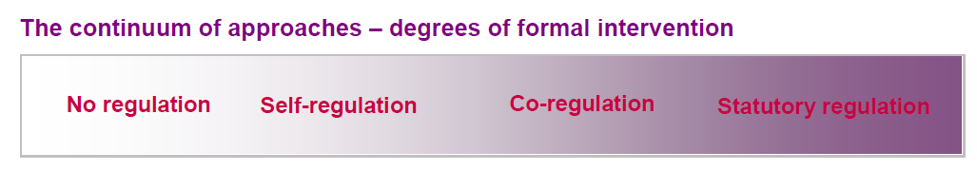

No regulation | Markets are able to deliver required outcomes. Citizens and consumers are empowered to take full advantage of the products and services and to avoid harm.
Self-regulation | Industry collectively administers a solution to address citizen or consumer issues, or other regulatory objectives, without formal oversight from government or regulator. There are no explicit ex ante legal backstops in relation to rules agreed by the scheme (although general obligations may still apply to providers in this area).
Co-regulation | Schemes that involve elements of self- and statutory regulation, with public authorities and industry collectively administering a solution to an identified issue. The split of responsibilities may vary, but typically government or regulators have legal backstop powers to secure desired objectives.
Statutory regulation | Objectives and rules of engagement are defined by legislation, government or regulator, including the processes and specific requirements on companies, with enforcement carried out by public authorities.

2.3 Voluntary agreements and standards

Figure 2: The Governance Triangle

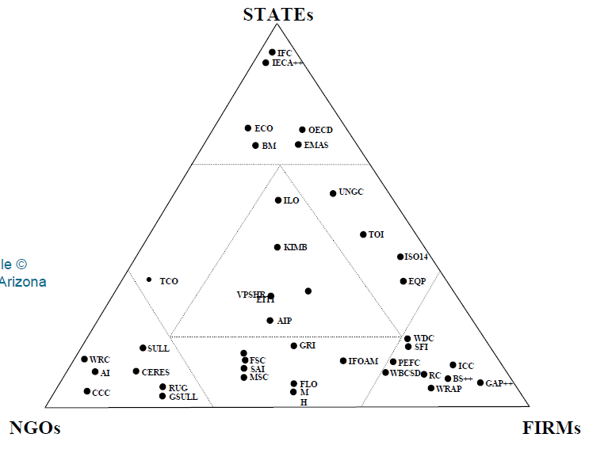
Regulation

Co-regulation

Self-regulation

A form of co-/self-regulation, voluntary agreements are usually concluded within an industry to improve product or service quality standards, but are also increasingly used to set standards to manage the wider (external) environmental and social impacts of products and services. The design of agreements are extremely varied and involve government, NGOs and business to different extents (see figure 2). Cooperation is especially important in ‘non-win-win’ situations where unilateral action from businesses subjects them to the risk of losing their competitive advantage and therefore the market itself would not deliver public interest outcomes. In these contexts, voluntary agreements can be vital in helping create level playing field between businesses.

Figure 3: ‘Win-win’ and ‘non-win-win’ situations
‘Win-win’ | ‘Non-win-win’
Cost neutral or net profits increased through a social or environmental improvement (e.g. waste-reduction strategies gaining brand advantage or reduced costs). | Market forces and sustainability push in opposite directions. If a company attempts to take the initiative unilaterally then its financial position will slide – first mover disadvantage.
Issues of investor or customer approval do not arise. | Businesses acting unilaterally will have difficulty obtaining the necessary support from investors and customers unless those groups have a particular interest in funding an initiative on the grounds of sustainability (i.e. ethical consumers).

Voluntary agreements could enable action in ‘non-win-win’ situations to deliver more sustainable products and services; for instance, by incorporating social/ environmental costs and passing them on to the consumer. Companies, however, are sometimes, although by no means always, reluctant to cooperate with competitors in such matters, fearing accusations of collusion or other anti-competitive behaviour.
Stretching voluntary agreements can also be a challenge for trade associations to facilitate. Héritier and Eckert observed: "...it was mostly special purpose associations that were created to govern self-regulation, thereby circumventing a typical collective problem of sectoral roof associations." One of their interviewees explained: "In an association you always have to find the smallest common denominator. You never can actively tackle a specific issue because then some members would object: what are you doing with our membership fees […] Therefore we have established the working group for PVC over the entire chain.”

2.3.1 When are self- or co-regulation appropriate?
Self-regulation is most effective when industry incentives are aligned with the interests of citizens and consumers. If insufficient, elements of statutory regulation can provide such incentives, resulting in co-regulation. Co-regulatory schemes may build on existing self-regulatory initiatives, introducing regulatory back-stop powers.

Figure 4: Self- and co-regulation: a comparison
Self-regulation | Shared Characteristics | Co-regulation
- potentially higher cost for business, lower cost for state  - promotes voluntary leadership and responsibility by business on public interest issues  - may have less signatories, and therefore sometimes be less demanding of participants, delivering less public benefit  - but less signatories can sometimes make it easier to find consensus and deliver stretching targets | - may be more costly to run than statutory regulation  - benefits from industry expertise  - better accountability for delivering on the objectives of agreements through reporting  - businesses go beyond legal compliance, providing more benefits to consumers/society  - more flexible and targeted than statutory regulation  - can provide opportunities for anti-competitive behaviour | - potentially lower cost for business, higher cost for state  - government involvement risks diluting voluntary leadership and responsibility by business on public interest issues  - on the other hand, relieves industry of some responsibility associated with establishing and operating the initiative  - enables carrots and sticks to be incorporated into agreements with government backing  - provides greater incentive for businesses to sign up/NGOs to participate  - increased signatories can sometimes deliver more stretching targets and greater public benefit  - on the other hand, increased signatories can sometimes make it harder to find consensus, delivering less public benefit – the hope is that government/ministerial leadership helps avoid this trap  - - flexible as to the degree of government involvement as co-regulatory initiative evolves

It is important to note that self- and co-regulation are not appropriate in every market or situation. Statutory regulation may be more appropriate where there is a highly concentrated or monopolistic market structure or where the issue at hand is unlikely to have a significant impact on the company’s commercial success or reputation.

2.3.2 Responsibility Deals, Collaborative Agreements and Cooperatition
‘Responsibility Deals’ are a concept introduced by the Conservative Party Working Group on Responsible Business in its report ‘A Light But Effective Touch’ (March 2008). They are intended to cover important social and environmental concerns such as ‘obesity, problem drinking, climate change and reducing and recycling waste’. According to the report, participants in Responsibility Deals would be drawn from business and business-representative bodies, NGOs and the voluntary sector, academic institutions, regulators, government bodies and investors.

One of the intended incentives for pursuing the concept is to be supervision of the project by the relevant Secretary of State as well as day-to-day management by a team of officials (the ‘Responsibility Deal management team’). Responsibility Deals as outlined by the Working Group are therefore probably best classified as voluntary agreements on the border of self- and co-regulation.

Professor David Grayson from the Doughty Centre for Corporate Responsibility has defined another type of voluntary agreements: ‘Collaborative Agreements’. These are ‘agreements made voluntarily between individuals and organisations from business, public sector and civil society, to achieve positive social impacts which would not be possible for one sector acting alone, to obtain’. Collaborative agreements have several characteristics, perhaps the most important of which being that all parties’ contributions depend on contributions of the others and if one party withdraws the collaboration fails. Such multi-stakeholder, cross-sectoral agreements are thought to deliver more substantial results than conventional public-private-community partnerships and also to produce significant social innovation and commercial opportunities.

An example of a collaborative agreement is the Finance Facility for Immunisation (IFFIm) project. Through the IFFIm, partners from the private, public and civil sector cooperated to deliver childhood immunisation in developing countries. This was achieved by each institution using its own unique contribution to release the potential of another. The private sector, a large financial institution, created a commercial bond to enable the public sector, national governments, to release resources to third sector NGOs which were then able to deliver the intervention.
Responsibility Deals, Collaborative Agreements and voluntary agreements/ standards more generally are examples of ‘Cooperatition’ in the marketplace. Cooperatition describes a process whereby in certain circumstances, where there is justifiable and evidenced public benefit, cooperation between competitors is not restricted, even where this results in price increases to consumers. A voluntary agreement may enable businesses to synchronise the timing of the improvement in standards, thus removing any first or second mover disadvantage.
Thus competing businesses collaborate in a public benefit initiative. Each business works towards the goals independently, which means that they will strive to do so in the most efficient way possible and compete on many detailed aspects of the change. Cooperatition synthesises the best traits of competition and cooperation. We believe it is key to nurturing a responsible economy.

2.4 Competition law and voluntary agreements
An important consideration in the process of drafting voluntary agreements must be compliance with competition/antitrust law. Many of the current uncertainties regarding what is allowable seem to be rooted in the end of the ‘notification’ process for voluntary agreements that existed prior to the harmonisation of competition law across the EU in the late nineties and a decision-making vacuum left in its wake.
Today all European competition regimes are based on the European model encompassed mainly in Article 101 and Article 102 of the Treaty on the Functioning of the European Union (TFEU). Article 101 prohibits agreements between two or more firms which restrict competition (subject to some limited exemptions) and Article 102 prohibits abuse of dominant position by a firm. As voluntary agreements are concluded between two or more firms, it is Article 101 and corresponding national provisions that are of relevance.

When you read old papers on competition law note that in the previous EC Treaty Article 101 was titled Article 81 and Article 102 was titled Article 82.

2.4.1 Anti-competitive agreements
Article 101(1) TFEU, as well as Section 2 of the UK Competition Act 1998, state that agreements between undertakings, decisions by associations of undertakings or concerted practices which may affect trade within the EU or UK respectively and which have the object or effect of preventing, restricting or distorting competition are prohibited, subject to certain exemption criteria.

Example: Government encouraged standardisation
In response to the findings of research into the recommended levels of fat in certain processed food, several major manufacturers of the processed foods agree, through formal discussions at an industry trade association, to set recommended fat levels for the products.
Although the fat levels are recommendations and therefore voluntary, as a result of wide publicity resulting from a government-funded advertising campaign, the recommended fat levels are likely to be implemented by all manufacturers of the processed foods. It is therefore likely to become a de facto maximum fat level in the processed foods. Consumer choice across the product markets could therefore be reduced. However, the parties will be able to continue to compete with regard to a number of other characteristics of the products, such as price, product size, quality, taste, other nutritional and salt content, balance of ingredients, and branding. Moreover, competition regarding the fat levels in the product offering may increase where parties seek to offer products with the lowest levels. The agreement is therefore unlikely to give rise to restrictive effects on competition within the meaning of Article 101(1).
As the Office of Fair Trading suggests, the risk of cooperation through voluntary agreements is that it may spill over into areas which raise competition law concerns, including price fixing, information exchange or foreclosure of competitors. Such practices are usually known as ‘hard-core’ restrictions and, although theoretically possible, agreements of this nature are unlikely to fulfil the necessary criteria for exemption.

An anti-competitive agreement can be exempted (allowed) by national or EU competition authorities if it fulfils four cumulative conditions from Article 101(3) TFEU:
a) It contributes to:
i) Improving production or distribution, or promoting technical or economic progress
ii) while allowing consumers a fair share of the resulting benefit; but
b) Does not:
i) Impose on the undertakings concerned restrictions which are not indispensable to the attainment of those objectives; or
ii) Afford the undertakings concerned the possibility of eliminating competition in respect of a substantial part of the products in question.

Heike Schweitzer writes: "In EU competition law... the relation between competition policy and public interest goals is complex. Private restraints of competition can have economic benefits which relate to public policy goals and bring about pro-competitive benefits... The "pure" view of competition policy oriented towards efficiency only incompletely reflects the reality of the plurality of legal institutions which frame the competitive process and influence it."

"It is not easy to conceptualize, then, how Art. 81(3) [now 101(3)] is to be applied by national competition authorities and courts as a matter of law, i.e. without allowing these institutions to exercise policy discretion... The benefit of the restriction for public policy must be established by the national court or competition authority itself. Within the limits of the working of Art 81(3), the reference point is the broad set of public policy goals set out in Art 2 [replaced in substance by Article 3 of the TFEU] and Art 3 [replaced in substance by Articles 3, 4, 5 and 6] EC Treaty. Upon linking the restrictive effect of these policy goals, a national court or competition authority must, within the limits of the proportionality principle established by Art. 81(3), decide whether a public interest of the [European] Community outweigh the loss of competition which results. In the absence of a clear hierarchy of goals, a court or competition authority, in making such value judgements, acts no longer in the role of a judge, but enters the field of policy making." These challenges are well illustrated by the OFT Dairy Investigation (see below).

Example: OFT Dairy Investigation - Price-fixing for British farmers?
- In 2007, Office of Fair Trading (OFT) issued a statement of objections against supermarkets and dairies regarding breaches of competition law relating to the exchange of commercially sensitive information on certain lines in 2002 and 2003.
- The companies stated that their actions were motivated by trying to help British farmers. At the time retailers and dairy firms were under pressure from farmers and politicians to give a better deal to their suppliers.
- This raises an interesting case for such conduct, which may not be immediately advantageous to the end consumer, to be allowed on the basis of wider social and economic sustainability benefits that were lost through a lack of cooperation.
- Clearly the approach the companies had adopted in 2002/3 did not comply with competition law. In 2007/8 reached early resolution agreements with Asda, Dairy Crest, The Cheese Company, Sainsbury’s, Safeway and Wiseman Dairies.
- In late April 2010 the OFT moved towards concluding the case, dropping some, but not all of the infringement findings. This also included an agreement with Tesco. The total fines imposed on the companies will be approx. £70m.

2.4.2 UK Competition law and voluntary agreements/ standards
Competition law in the UK is enforced by several regulatory bodies, with the Office of Fair Trading (OFT) having the greatest breadth of responsibilities. However, as OFT Chief Economist Amelia Fletcher notes, “the economic issues raised by self-regulation are not commonly discussed by national competition authorities or consumer enforcement bodies.” . Arguably the most developed thinking amongst UK regulators thus far has been presented by OFCOM, the independent regulator and competition authority for the UK communications industries, whose classification of regulation types we use in this guide.
In order to assess whether infringement of Section 2/ Article 101(1) occurred, four key elements need to be analysed (see figure 5).
Figure 5: Application of OFT Guidance to voluntary agreements
Section 2/ Article 101(1) infringement - Four key considerations:
- Whether an agreement between undertakings, a decision by associations of undertakings or a concerted practice occurs | OFT guidance states that “Self-regulating bodies are associations of undertakings and the Chapter I prohibition and Article 101 apply to their rules and decisions in exactly the same way as to those of any other association of undertakings.”
- Whether there is the possibility of an appreciable effect on trade from an agreement  - Whether there was appreciable restriction of competition by object/ effect from an agreement | It is likely that the effect on trade and/or restrictions of competition will not be appreciable as long as the participants have sufficient flexibility and independence in how to carry out the objectives of the agreement.
- Whether the agreement fulfils the necessary conditions for exemption | See four cumulative conditions of Article 101(3) TFEU – section 2.4.1 – and section 8/9 of the UK Competition Act (1998).

The ‘Partial Impact Assessment of powers to require charges for single-use carrier bags’ (Defra, 2008) concluded: “…the Government has been unable to orchestrate a sufficient response to public demand for a huge reduction in carrier bag usage. Government intervention is needed because retailers are unlikely to be able to achieve this themselves without resorting to charging for bags – and their ability to do this collectively is impeded by Competition Law.

“…To be statutorily exempt, an agreement would need to fulfil four cumulative criteria. These criteria rely very heavily on economic considerations, and include both the need to prove that the agreement is necessary to achieve its stated ends, and that consumers would receive a fair share of the resulting benefit. Designing a voluntary agreement which meets these criteria may be possible, but will require a great deal of detailed work, including external legal advice, to minimise the risk of successful challenge.”

We believe the difficulty of achieving statutory exemption may have been exaggerated in this assessment, but in part this comes down to how “fair share of the resulting benefit” is calculated.

The Partial Impact Assessment went on to state: “Another potential route for exemption is that the Competition Act provides for the Secretary of State from [BIS] to make an exclusion from the Act’s prohibition of anti-competitive arrangements. Such exclusions can only be made where there are “exceptional and compelling reasons of public policy”. It is worth noting that only two such exclusions have been provided to date (both for defence-related matters) and any UK exclusion order would not disapply the prohibition under the EC Treaty of any agreement that might have an effect on inter-state trade.”

We believe the exemption route has been underused as a route by which to enable non-win-win voluntary agreements, providing a higher degree of comfort than SFOs offer (see section 3.5). If competition authorities always wait for other government departments/ legislative mechanisms to come into play this risks stifling the wider application of co-/self-regulation.

2.4.3 EU Competition Law and Voluntary Agreements/ Standards
The European Commission’s Guidelines on the applicability of Article 81 of the EC Treaty to horizontal cooperation from 2001 provide guidance as to agreements concerning environmental standards. According to paragraph 185, an agreement may fall outside the scope of Article 81 (now 101) “if no precise individual obligation is placed upon the parties or if they are loosely committed to contributing to the attainment of a sector-wide environmental target”. On the other hand, environmental agreements come under Article 101 “if the cooperation does not truly concern environmental objectives, but serves as a tool to engage in a disguised cartel, i.e. otherwise prohibited price fixing, output limitation or market allocation.”

The ‘EU Guidelines on horizontal cooperation agreements’ summary is fairly positive with regards to collaborative agreements/standards: “Agreements on standards – Standardisation agreements have as their primary objective the definition of technical or quality requirements with which products, production processes or production methods must comply. From the competition viewpoint, it is necessary to check that agreements of this type are not used for other purposes, i.e. to restrict competition on the market.”

On environmental agreements, the EU guidelines summary states: “Environmental agreements – Environmental agreements are agreements by which the parties undertake to reduce pollution, as defined in environmental law, or to achieve environmental objectives. In general, the Commission is favourably disposed towards the use of agreements of this type to achieve environmental aims. However, where cooperation does not truly concern environmental objectives but serves to conceal anti-competitive practices, the competition rules apply.”

Following the adoption of the Treaty on the Functioning of the European Union, new Draft Guidelines on the applicability of Article 101 to horizontal co-operation agreements have been published by the Commission. The Draft does not contain a separate section on environmental agreements, merely stating that agreements “setting out standards on the environmental performance of products or production processes” are covered by the general provisions on standardization. These state that, “where participation in standard-setting, as well as the procedure for adopting the standard in question, is unrestricted and transparent, standardisation agreements which set no obligation to comply with the standard and provide access to the standard on fair, reasonable and non-discriminatory terms do not restrict competition within the meaning of Article 101(1).”

2.4.4 Competition Law in different international territories and Voluntary agreements/ standards

Australia

One of the most progressive competition law regimes with regard to considering public policy matters in the assessment of anti-competitive agreements is the Australian regime. The Australian Trade Practices Act (1974) is the main piece of legislation aiming to prevent anti-competitive conduct and to encourage competition and efficiency in business. The Australian Competition & Consumer Commission (ACCC), however, can grant immunity from legal action when the public benefit from the anti-competitive conduct outweighs any public detriment. Businesses may obtain clearance by applying for an ‘authorisation’ or submitting a ‘notification’ with the ACCC.

An application has to contain, among others, the following submissions:

How the conduct operates or is likely to operate in practice

How the conduct has been framed to minimise the public detriment

The public benefits which result or are likely to result from the proposed conduct

Who are the beneficiaries of the conduct and how are the benefits distributed

The period for which authorisation is sought

Figure 6: Australian anti-competitive agreements authorised on the grounds of public benefit

Price fixing allowed with dairy farmers for period of five years

Health food co-operative allowed for five years to collectively negotiate the terms and conditions (including price) at which they will obtain food products from various suppliers and distributors

Retailer Alert Scheme sets out voluntary supplier/ retailer code for the withdrawal of alcohol products deemed to be inappropriately named or packaged

South East Potato Growers Association allowed to engage in collective negotiations on behalf its members with two potato buyers

Three year authorisation for three Liquid Petroleum Gas (LPG) producers collaborating in a project to collectively agree contracts (including price) for sales to customer(s)
Israel
According to the Israeli Restrictive Trade Practices Act 1988, voluntary agreements that involve any sort of ‘restrictive arrangement’ must be approved by the Antitrust Tribunal. Decisions by the Tribunal regarding whether to approve a restrictive arrangement are based on public interest considerations. Most of the considerations can be attributed to economic and efficiency concerns. However, the Antitrust Tribunal weighed environmental concerns in approving a restrictive arrangement between major retail chains and beverage companies, regarding collaboration in order to establish and operate a recycling company. The decision demonstrated that environmental concerns may be considered as promoting the public interest.

Other territories
A few countries, namely South Africa and Spain are starting to put public policy objectives at the heart of their competition legislation. The German and Danish competition authorities systems similar to the UK OFT’s ‘Short-Form Opinion’ procedure that enables them to evaluate voluntary agreements. The Netherlands Competition authority (NMa) devoted a chapter within their 2009 Annual Report to the challenge of how to incorporate public interest factors into their decision-making, noting that “if a competition authority wishes to take into account a public interest, it should find out whether there is a political basis that can justify the anti-competitive restrictions. Such a justification would ideally rest on a political decision that clearly defines the policy objective that is involved, as well as the role that self-regulation is expected to play in achieving this objective.” The NMa recognised environmental benefits in the assessment of a collaborative agreement between battery producers and importers with respect to the collection and processing of used batteries.

3.0 Compliance
The most important guidance for the next few years as regards compliance with EU and consequently also UK competition law will be the 2010 Horizontal Guidelines (see 2.4.3. above). The Draft provides guidance on several issues which will be of special importance in the assessment of voluntary agreements compliance, including rules on information exchange and the requirement of pass-on to consumers.

3.1 Information exchange
The main competition law concern that may arise from voluntary agreements is an exchange of information between competitors which would make it easier for them to predict each other’s market strategies and adjust their behaviour accordingly. This may lead to a cartel. In other words, it may enable participants to fix prices or allocate customers or markets.
In order to assess whether an information exchange could potentially lead to restrictions of competition, the nature of the information must be considered. According to the Guidelines, exchange of ‘commercially sensitive information’ is most likely to be caught by Article 101. This includes price-related information, customer lists, production costs, quantities, turnovers, sales, capacities, qualities, marketing plans, risks, plans, investments, technologies, R&D programs and results. On the other hand, exchanges of “genuinely public information” – information that is equally easy to access for everyone – are unlikely to constitute an infringement of Article 101. ‘Aggregated’ data – non-individualised information which cannot be traced to a specific competitor – also reduces the likelihood of the information exchange to restrict competition.

Based on case law, PE 100+ set out in their membership rules that:
- Individual company data must not be disclosed to competitors, either in the published survey or during its compilation, although exchange of ‘historic' data more than 12 months old may be disclosed in the report or survey results;
- Data (which is not ‘historic') should be disseminated in an aggregated form which does not expressly identify a particular participant or enable identification by ‘reverse engineering' of data (for example, by ensuring that the aggregated data includes input from at least three participants);
- Information disseminated should not be accompanied by comment, analysis, observation or recommendation (in particular, on pricing); and
- Participants should not discuss the report or survey results, whether at or outside of Association meetings.

Best practice
- Organisations managing voluntary agreements/standards involving information exchange could ensure information exchange is facilitated through an independent third party (see Appendix 5);
- The approach to information exchange could be codified in an information-sharing agreement, such as the model agreement developed for REACH.

3.2 ‘Pass-on’ of a fair share of benefits to consumers
If a restriction of competition under Article 101(1) is found, Article 101(3) can be used in order to determine whether the voluntary agreement in question is exempt. ‘Pass-on’ of a fair share of benefits derived from the agreement to consumers is one of four cumulative exemption criteria that must be fulfilled in order to allow the agreement to proceed. The other criteria are efficiency gains, indispensability and no elimination of competition (as outlined in section 2.4.1.).
With regard to standardisation agreements, “efficiency gains attained by indispensable restrictions must be passed on to consumers to an extent that outweighs the restrictive effects on competition”. The pass-on of benefits to consumers through an agreement/ standard needs to be assessed on a case-by-case basis.
Example: Environmental standards – the CECED decision
Almost all producers of washing machines agree, with the encouragement of a public body, to no longer manufacture products which do not comply with certain environmental criteria (e.g., energy efficiency). They will be replaced with more environmentally friendly, but also more expensive products. Product variety is reduced resulting in less choice for consumers and prices will probably rise. Therefore, the agreement is likely to give rise to restrictive effects on competition within the meaning of Article 101(1).

However, the new products are more technically advanced, offering qualitative efficiencies to consumers. Long-term cost efficiencies also result from lower running costs in the form of reduced consumption of water, electricity and soap. Moreover, environmental benefits for society allow consumers a fair share (pass-on) of the benefits even if no benefits accrue to individual purchasers of machines. The efficiency gains outweigh the restrictive effects on competition.

3.3 Trade associations, self-regulation bodies and membership organisations
Voluntary agreements are often initiated, implemented and managed through trade associations, self-regulation bodies and membership organisations. In order to ensure compliance with competition law, these bodies should inform their members of the potential risks of activities which might have an influence on competition. This can be done in a multitude of ways, from issuing formal competition compliance membership rules to discussing the issues at meetings.

3.3.1 Membership rules – how to comply with competition law
Companies should check that clear competition law membership rules and guidance are established for business groups of which they are a member. These must then be put into practice. The tips that follow are drawn from Cefic’s competition compliance guide for REACH.

Figure 7: Compliance through effective facilitation of collaborative activities
ORGANISATION OF ACTIVITIES
✓ | ✗
DO have an effective organisation (e.g. by signing appropriate agreements including rules for defining items such as membership, data sharing, cost sharing, adoption of an EC competition law compliance set of rules) | DO NOT work in a disorganised way. If you have rules or sign an agreement apply these in full and ensure they are followed

TYPE OF ACTIVITIES
✓ | ✗
DO always apply UK/EC competition law compliance to any type of voluntary agreement/ standard related activities: not only formal meetings, but also activities such as conference calls, use of IT systems, exchange of correspondence, e-mails, informal meetings | DO NOT engage in prohibited activities during social gatherings incidental to your lawful activities or otherwise; UK/EU competition law rules will equally apply to these

LEGAL ADVICE
✓ | ✗
DO recognise and acknowledge that an issue or question may be complex and needs to be handled in a proper way  DO ask for guidance at an early stage  DO always remember that if you are uncertain DO NOT act. Ask and wait for the answer, before acting. | DO NOT presume that you know all about competition law rules just by reading this guide. It is neither exhaustive nor a substitute for legal advice.  DO NOT wait to seek appropriate legal advice and DO NOT ignore important questions as these will not be resolved by themselves.

There are a number of UK/EU trade associations that are now providing competition compliance policy/ guidance to their members. We outline just a few examples as illustration:
- The Association of British Healthcare Industries identifies three specific areas that require particular attention in the light of the competition rules: the association’s membership rules; the industry-wide standards it may set; and information exchanged at association meetings.
- BIMCO, an independent shipping association, reminds members and other participants at any of its meetings, forums, working groups other events that any action or agreement which may potentially prevent, restrict or distort competition - such as exchanging sensitive information, or setting standards that exclude competitors - is likely to be unlawful.
- The PE100+ Association has issued very detailed guidelines on competition compliance for its members, including definitions of key legal terms, guidance as to membership rules, information exchange, industry standards, information exchange, benchmarking and market surveys as well as conduct at association meetings. (See Appendix 2)

3.3.2 Chairing, administering and participating in meetings
Competition law compliance rules need to be put into practice by all participants at Trade Association meetings with the support of an active chairperson. Figure 8 sets out best practice essentials, figure 9 illustrates these principles in practice and figure 10 provides a checklist for meetings.

Figure 8: Best practice at meetings
RECORD KEEPING
✓ | ✗
DO keep a written record of your scheme activities  DO ensure retention of the agenda, minutes and other important documents | DO NOT believe that written communications are discouraged. On the contrary, if you are involved in an inquiry conducted by a competition authority your defence may rely heavily on accurate records prepared in the ordinary course of scheme activities which  have far more credibility than after-the-fact oral explanations

NECESSARY VIGILANCE
✓ | ✗
DO protest against any inappropriate activity or discussion (whether it occurs during meetings, conference calls, social events, or when working via electronic means – for example using a dedicated intranet).  Ask for these to be stopped; dissociate yourself from these and have your position clearly expressed in writing, ideally in the minutes or in any case as soon as possible after the respective meeting or activity  If a third party or trustee is used to facilitate the meeting, he/she should stay in the room, stop the inappropriate activity and record the incident | DO NOT pursue activities in breach of EU/UK competition law

Figure 9: Good practice examples
Competition Law Policy reminder at bottom of Agenda
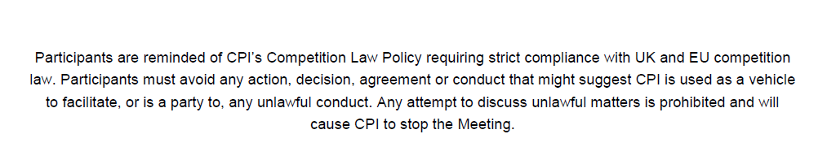

Reminder at start of meeting on Powerpoint slide
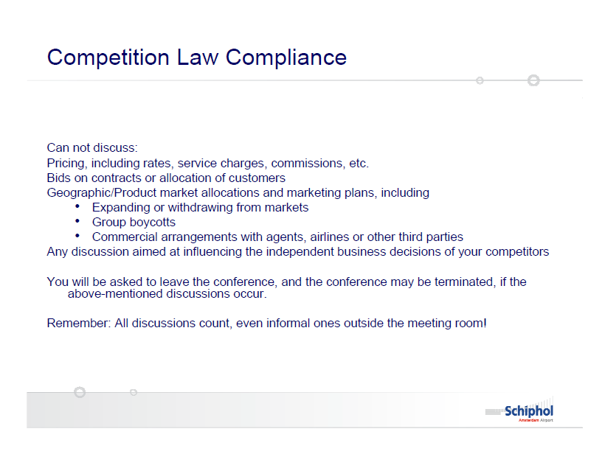

Detailed record in meeting minutes
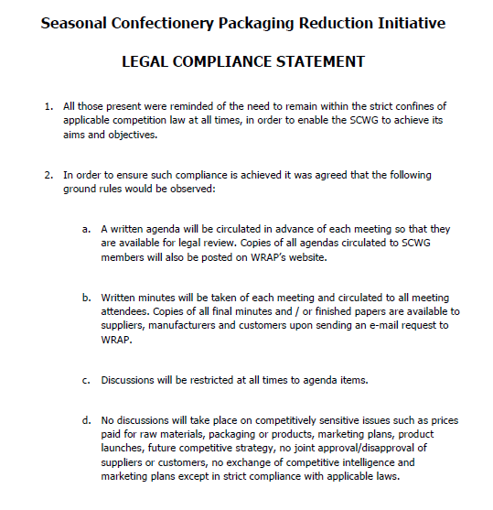

Figure 10: Meetings checklist
Actions | Completed ✓
Circulate the agenda in advance
Stick to the agenda for the meeting discussions
Have an accurate participation list (to be signed by each participant) and minutes
Distribute this leaflet at the beginning of the first meeting (and to newcomers) and always refer to it and to EC competition law compliance at the beginning of each meeting
Have detailed minutes
Limit social contacts outside of meetings, and continue to abide by these guidelines at such social events, if any

3.4 Corporate compliance
Corporate compliance with competition rules and their coordination with public policy objectives is second nature to many businesses today.

Why comply? “Because complying with the law is an integral part of the ethical basis on which good corporate citizens do business.” Ann Riley, Associate General Counsel Antitrust, Shell International

Positive guidance should be given to Board Members and employees regarding voluntary agreements/ standards and their benefits, as well as the risks associated with infringement of competition law. Nearly all the corporate competition law policy and guidance that we reviewed in the production of this guide failed to specifically address compliance issues arising from collaboration through voluntary agreements and standards.

Best practice
- Widely voice the need for having EC competition law compliance rules that cover participation in voluntary agreements/ standards, and adopt a robust system that is applied effectively;
- Demonstrate commitment by putting company competition compliance policy/guidelines in the public domain. Examples: Agility Logistics, BBA Aviation, Costain Group and Roche (see Appendix 1);
- Include EC competition law compliance in internal management process for voluntary agreements in which company participates;
- Make sure that all participants in voluntary agreements/standards processes receive adequate EC competition law compliance training;
- Strictly limit the participation of marketing and business people in trade associations, business fora.

3.5 The OFT’s Short-Form Opinions (SFO) procedure
It can be complicated to self-assess the legality of some types of voluntary agreements/ standards. The Short-Form Opinions (SFO) procedure, currently being introduced by the OFT due to demand from the business community has the potential to be of welcome assistance. It will hopefully help businesses looking to move into innovative and potentially beneficial collaborations progress more rapidly with their agreements, which, previously, might even have been discarded due to concern as to competition law infringements.

An agreement has to fulfil several conditions in order to be eligible for the SFO Procedure:
- The SFO should be capable of clarifying a novel or unresolved question of law that would benefit a wider audience;
- The competitor collaboration should be prospective, i.e. not either hypothetical or already in place;
- The SFO should relate to a horizontal agreement between competitors and the agreement should have a material link to the UK;
- The requesting parties must be willing to prepare a joint statement of facts on which the OFT will base its analysis, and see a non-confidential version of the joint statement of facts published alongside the SFO;
- The matter which is the subject of the SFO request must not be:
- similar to a case already being investigated by the Commission or a national competition authority;
- the subject of litigation; or
- already being considered in the context of an Opinion by the European Commission or a national competition authority.

4.0 Crafting effective voluntary agreements and standards
Over the past two decades, as business involvement in voluntary corporate responsibility initiatives has exploded, so too have the number of self/co-regulatory schemes. Their leadership, design, and impact is varies widely. This guide provides a starting point on how to craft effective voluntary agreements/standards, which is supplemented by advice from competition authorities, as well as a much more detailed framework from the ISEAL Alliance. An important part of competition law compliance, and, for example, presenting evidence for an SFO, is that the market impacts of an agreement/standard are fully understood. The legal implications of voluntary agreements that seek to go beyond the EU’s borders should also be examined.

Good practice criteria in establishing new schemes
OFCOM has proposed a set of useful best-practice criteria for the establishment of new schemes (figure 11 below).

Figure 11: Best-practice criteria for the establishment of new schemes
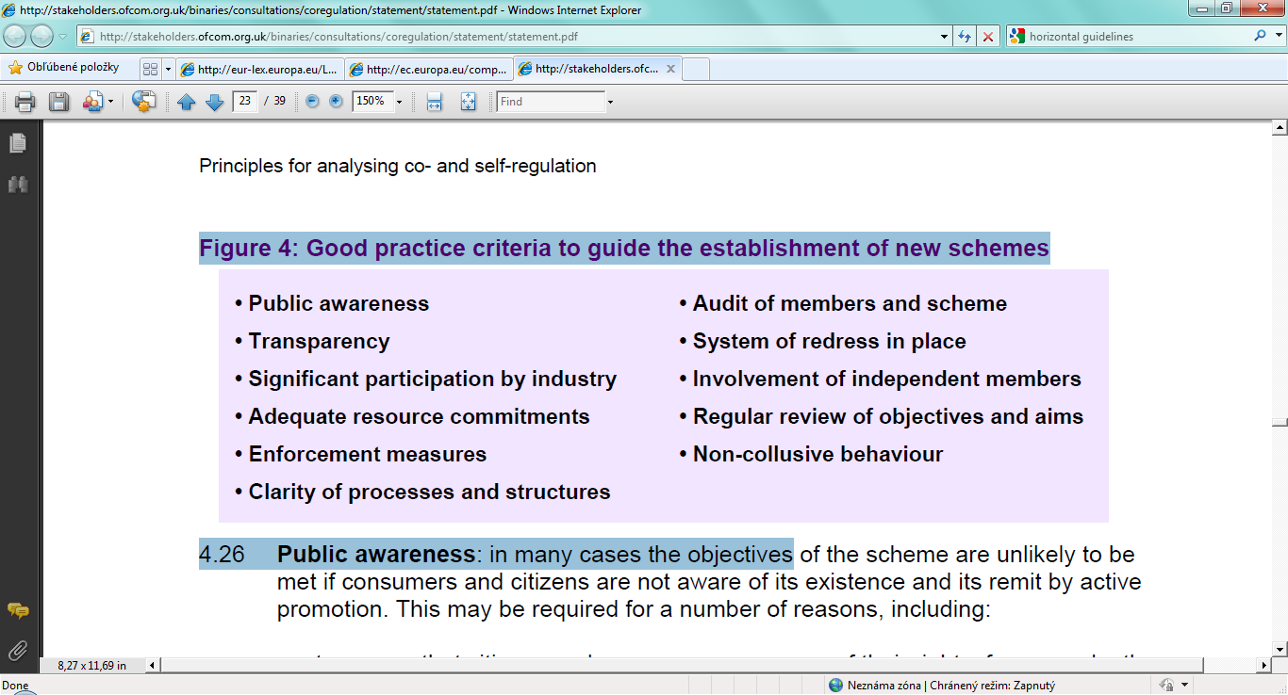

More detailed guidance for crafting voluntary agreements/standards is available from the ISEAL Alliance. The ISEAL Alliance is an international non-profit organisation that codifies best practice for the design and implementation of voluntary social and environmental standards systems. They have built upon ISO, OECD and WTO principles and codes of good practice relating to the development of standards/Processes and Production Methods (PPMs).

4.1.1 The ISEAL Codes of Good Practice
The ISEAL Alliance has developed three Codes of Good Practice:

The Standard-Setting Code
Code of Good Practice for Setting Social and Environmental Standards

The Impacts Code
Code of Good Practice for Assessing the Impacts of Social and Environmental Standards

The Verification Code
Code of Good Practice for Verifying Compliance with Social and Environmental Standards

The Standard-Setting Code specifies general requirements for transparent and accountable preparation, adoption and revision of standards that address social and environmental practices. This Code emphasises the importance of open standard-setting processes, as well as broad and balanced stakeholder engagement in the development and decision-making around standards.

Requirements of the Code include:
- The social, environmental and/or economic objectives of a standard shall be clearly and explicitly specified in the standard
  - Examples of legitimate objectives: environmental protection, human health or safety, animal or plant life or health, labour and social welfare, cultural considerations.

- Standards shall be no more trade-restrictive than necessary to fulfil the legitimate objectives of the standard.

- The structure of a standard shall form a logical framework such that all the requirements clearly contribute to the achievement of the standards’ objectives.

- In defining the content of a standard, the standard-setting organisation shall seek to complement and build on relevant regulatory requirements and to take account of market needs, as well as scientific and technological developments.

- Where international standards are to be adapted for application at the national or regional level, the standard-setting organisation shall develop interpretive guidance or related policies and procedures for how to take into account local economic, social, environmental and regulatory conditions.

For more information see Appendix 3.

4.2 Understanding market impacts
The OFT has provided a classification (figure 12) which they have used as a framework to consider the market impacts of different types agreements and standards.

Figure 12: Types of agreements and standards
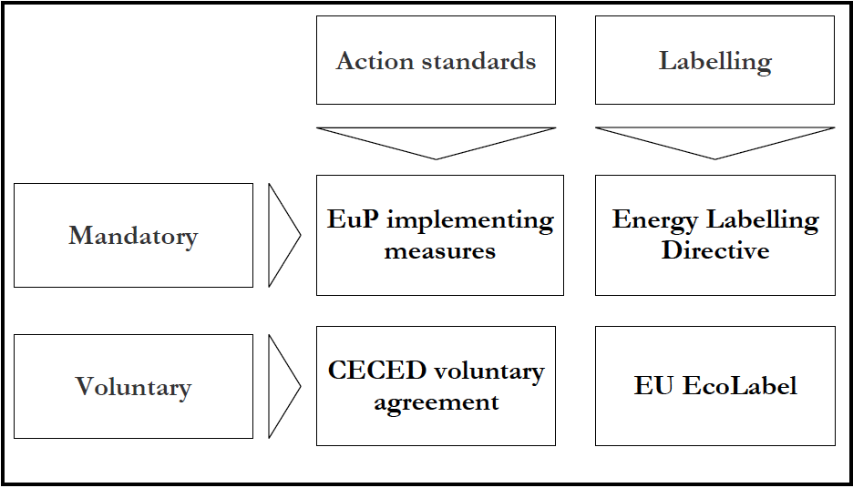

Mandatory standards (e.g. minimum energy efficiency standards from the EuP Directive) would fall into the category of statutory regulation, whilst the voluntary standards provide further examples of co-/self-regulation.

4.2.1 Pro-competitive effects of voluntary agreements and standards
Product standards have pro-competitive effects if they open up new dimensions for competition to take place, or trigger changes in the market environment which make competitive activity more likely. Product standards can also make the product market more competitive by creating a common standard, and increasing incentives to innovate. These pro-competitive effects may be the result of either mandatory or voluntary standards.

From a sustainable development perspective if standards for products and services that sustain local and global ecosystems are not established then economies risk collapse, and competition/ business activity will cease.

4.2.2 Negative effects of voluntary agreements and standards
Negative outcomes for consumers can arise in relation to price, product quality, choice or innovation. Agreements regulating to quality risk the following potentially negative impacts on competition:
- Asymmetric impact on competitors – advantage to some businesses over others could result in a lessening of competition (e.g. by restrictions to entry) and higher prices to consumers
- Quality levels become too high – agreements excluding lower quality products could restrict choice for consumers. Many organisations, including The Cooperation Incubator, argue that where environmental and social impacts are detrimental to the public interest/ sustainable development, choice-editing may be required.
- Innovation is limited – potentially beneficial innovation could be dampened if self-regulation schemes are prescriptive about how quality standards must be met.
- Conduct restrictions – restrictions on advertising, for example, may harm competition as advertising is a mechanism through which businesses compete.
- Preventing inefficient businesses from failing – inefficient businesses could benefit from their associations with efficient businesses as members of a self-regulation scheme and could therefore ‘survive’ longer than in more competitive market conditions.

The OFT has mapped out in tabular form these distortions of competition that can arise from different standards in an imperfectly competitive market (figure 13 below).

Figure 13: Possible distortions of competition related to the type of standards
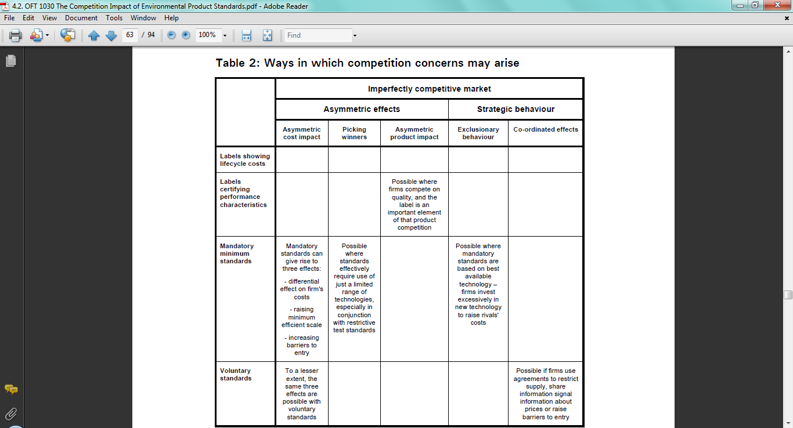

4.3 The OFT self-regulatory scheme assessment model
The new OFT model below provides a useful tool for undertaking an assessment of the design of a new agreement or doing a comparative study of existing agreements. The first diagram sets out Objectively Verifiable Indicators around difference aspects of a scheme and the second diagram sets out more specific indications and some Means Of Verification.
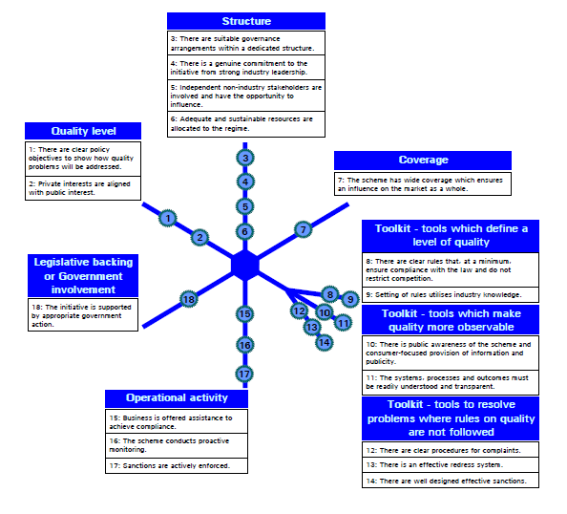

Source: ‘Policy statement: The role of self-regulation in the OFT's consumer protection work’

4.4 Voluntary agreements that go beyond national and EU borders
In assessing whether agreements that deliver social/ environmental sustainability benefits to producers and communities outside the EU could be exempted from the Article 101(1) prohibition, the criterion of pass-on of a fair share of benefits to consumers and market concentration are important factors to consider.

Whilst considering Fair Trade and non-governmental trade-related sustainability assurance schemes, the European Commission advised in 2009 that “Private Trade-related Sustainability Assurance Schemes and the WTO Trade liberalisation can offer opportunities for economic growth and sustainable development. ...Private initiatives that operate through essentially voluntary participation are consistent with a non-discriminatory multilateral trading system. Any government intervention or regulatory mechanisms relating to such labelling schemes, while not problematic per se, need to take account of WTO obligations, in particular to ensure their transparent and non-discriminatory functioning.” The Commission went on to state that the key WTO principle to observe was ensuring transparent and non-discriminatory functioning of the labelling schemes.
In developing their framework ISEAL Alliance has drawn upon the following WTO agreements:
- WTO Agreement on the Application of Sanitary and Phytosanitary Measures (SPS)
- WTO Agreement on Technical Barriers to Trade (TBT) Annex 3: Code of good practice for the preparation, adoption and application of standards
- WTO Agreement on Technical Barriers to Trade (TBT) Second Triennial Review Annex 4: Principles for the Development of International Standards, Guides and Recommendations with Relation to Articles 2, 5 and Annex 3 of the Agreement
ISEAL Alliance also utilise ISO and OECD principles and codes of good practice (see section 4.1.1 and appendix 3).

A contrast to the brief but favourable European Commission broad assessment of Sustainability Assurance Schemes is the example of the Australian Competition and Consumer Commission (ACCC) authorising a voluntary agreement with international application. Ethical Clothing Australia is a voluntary ethical trading initiative, in other words a self-regulatory scheme. It assists businesses in the garment industry ensure that homeworkers from countries other than Australia are employed according to relevant award conditions. The scheme was authorized by the ACCC, the public benefit of the scheme (then called ‘The Homeworkers Code’) consisting of:
- lessening the risk of exploitation of a susceptible group
- improving the flow of information to homeworkers, and
- facilitating compliance with statutory requirements.

5.0 Co-regulation and self-regulation in practice
There are now many examples of successful co-/self-regulatory agreements around the world. Here we profile just a few that considered carefully how to comply with competition law in their operating procedures and design.
The Cement Sustainability Initiative (CSI) - aims to:
- Reduce CO₂ emissions from cement production, curb emissions from significant pollutants other than CO₂;
- Explore what sustainable development means for the cement industry;
- Identify actions and facilitate steps cement companies can take, individually and as a group, to accelerate progress toward sustainable development;
- Provide a framework for other cement companies to become involved;
- Create the content and context for further stakeholder engagement.
CSI is a global effort by 23 major cement producers with operations in more than 100 countries who believe there is a strong business case for the pursuit of sustainable development. Collectively these companies account for about one third of the world’s cement production and range in size from very large multinationals to smaller local producers. To date the CSI remains one of the largest global sustainability programs ever undertaken by a single industry sector. The CSI website makes explicit reference to the need of competition law compliance and uses a third party for data exchange.
Courtauld Commitment – aims to reduce the carbon impact of grocery packaging by 10%, UK household food and drink waste by 4% and traditional grocery product and packaging waste in the grocery supply chain by 5% (including both solid and liquid wastes) by 2012. The Courtauld Commitment is facilitated by WRAP, who sought legal advice on competition law compliance as the scheme moved into second phase.

Federation House Commitment – aims to help reduce overall water usage across the Food and Drink industry by 20% by the year 2020
Expand

Halving Waste to Landfill – aims to halve the amount of construction, demolition and excavation waste going to landfill by 2012
Expand

6.0 Challenges and opportunities
For more co-/self-regulation to emerge, we believe multiple stakeholders – particularly consumers – must be engaged in the process of conceiving social and environmental regulation and monitoring its effectiveness. In section 6.1 we propose ‘RaceToTheTop.org’ as a new internet platform that could enable this active participation. With fresh ideas for new co-/self-regulation emerging we set out in section 6.2 the improvements in the official guidance and tools needed, and in sections 6.3 and 6.4 we focus particularly on resources that might provide the evidence base for co-/self-regulation to address environmental and social sustainability concerns.

6.1 Mapping the landscape and engaging stakeholders: RaceToTheTop.org
‘RaceToTheTop.org’ is a provisional name for a concept The Cooperatition Incubator is developing for a website that will overtime have the functionality to:
- enable comparison (by consumers, for example) of companies‘ support and participation in relation to voluntary agreements and standards, as well as the impact of those voluntary agreements and standards;
- provide users with associated information about the industries, companies and products etc. using a Wikipedia-type platform to underpin other functionality;
- harness the encouragement of website users for the initiation of work by companies towards new voluntary agreements and their input for all stages of the process;
- serve as a tool assisting with the scrutiny and development of existing voluntary agreements and standards.
This vision of ‘RaceToTheTop.org’ extends the suggestion of the ‘Conservative Working Group on Responsible Business’ report (2008) that with more than 30 Private Voluntary Initiatives (e.g. FSC) in existence a biannual review of their progress should be commissioned to discover the lessons learned.
The website is be intended ultimately to cater and appeal to the widest possible range of users, so that their participation can overcome the real possibility that, even if exemptions to competition law were more readily available in the EU, that businesses/ trade associations would not take them up to a sufficient extent. This would be due to a lack of economic incentive, particularly in the short term, and may be borne out by the Australian example.
The information on the website, including references to Fair Trade/FSC accreditation, for example, could also be used to provide the basis for a holistic assessment of companies corporate responsibility practices.
We believe this would enable bottom up, as well as top down, development of Responsibility Deals – and/or trade associations or regulatory agencies (not just Whitehall) to take on more of a leadership role.

6.2 Improving co-/self-regulation guidance and tools
The Cooperatition Incubator has argued over the past two years for further research to enable competition law and guidance to do a more effective job of enabling voluntary responsible business practices where appropriate. As the OFT’s Chief Economist has acknowledged self-regulation has not been significantly addressed by the academic economic literature. Our exploration of the issues has identified a number of issues at a national, European and International level that would appear to need to be examined. We would encourage the business community and other stakeholders to pursue resolution of these uncertainties.

National guidance and process improvements
1. Develop and then apply a framework to identify those issues demanding co-/self-regulation in order to incorporate external costs
Evaluate social and environmental indicators to strategically plan where the UK government envisages:
- No regulation - allowing normal competition to run its course thereby retaining the benefits of price efficiency already encompassed within the current system, but risking the neglect of social/ environmental standards; versus
- Self-regulation, co-regulation, regulation - delivering environmental and social sustainability objectives where this is deemed more important than pure efficiency-focused competition.

A good example of this in practice is the Defra Food Strategy 2030, which acknowledges the “Government’s core role in the UK food system is to correct market failures where they arise (for example distortions to the food economy caused by poor information, imperfect competition, the failure to price externalities and the under-provision of public goods), and to ensure that social equity is safeguarded…Government will favour voluntary industry-led and owned measures wherever possible, but we recognise that regulation may be required in some instances.” We believe a vital next step for Defra will be to map the market failures and appropriate responses. The same principle applies in other sectors with significant environmental and social impacts.

Businesses and other stakeholders should continue to be invited to contribute to such processes.

2. Research to clarify how to minimise the anti-competitive effects of voluntary agreements and quantify their Total Net Benefits
Voluntary agreements need to be carefully structured so that harmful anti-competitive effects (for example, restricting market entry) are minimised. This is why the case for any form of regulatory intervention on environmental and social issues must be built on a solid evidence base. Voluntary agreements in ‘non-win-win’ situations should typically only set out performance targets, rather than the specific cost details of product/ service changes. Robust and independent assessment mechanisms need to be developed to better understand the consumer price increases and net benefit that a range of non-win-win voluntary agreements/ standards may facilitate.

For further discussion see sections 6.3 and 6.4.

3. Remove conflicting signals by introducing new guidance
There appears to be contradictory guidance in this area. Broadly it appears the EU is more amenable to voluntary agreements than is reflected by the UK competition authorities/ Department for Business, Innovation & Skills (BIS). BERR (now BIS) Advice for officials of Government and devolved administrations: ‘Competition law: issues which arise for business when the government or lobby groups seek to encourage businesses to work together to deliver desired policy outcomes’ (2008) states: “Recently businesses in various sectors, including retail, have shown concern over pressure being applied to them to enter into voluntary agreements or concerted practices to deliver public policy outcomes. This is often in response to a particular issue that maybe in the public eye through high profile media campaigns. Examples of such engagement include the delivery of environmental or public health policy objectives.

“…Agreements are generally considered bad for consumers and productivity because they undermine the need for businesses to reduce their costs and increase their quality to succeed. Hence, if evidence shows there is a valid reason to phase out a product or behaviour, then it is best to consider whether other proportionate, but not illegal, options are available. This may include an appropriate legislative vehicle. This may seem disproportionate to the issue that is being addressed but will give legal certainty and may, in the final analysis, be less costly for business.”

Whilst this guidance document was aimed at a Civil Service audience, it was widely read and had a deterrent effect (along with the Dairy Investigation) on companies’ appetite to collaborate on complex responsible business issues. New guidance should address the mixed signals to the business community.

4. Use a range of mechanisms to increase business confidence in voluntary agreements compliance with competition law
a) Promote the ISEAL Alliance Codes of Practice and invest in building the capacity of trade associations and other intermediaries facilitating the development of voluntary agreements that are statutorily exempt (fulfilling the four cumulative criteria): The Portman Group Code of Practice was authorised under the previous UK competition law framework – the Restrictive Trade Practices Act 1976. Today the OFT operates a process for approving Consumer Codes of Practice. Whilst there may be an aversion to extending this to cover sustainable development-related voluntary agreements/ standards, we suggest that the OFT considers recognising the ISEAL Code of Practice as a suitable generic framework for the development of social and environmental voluntary agreements. It is already cited in European Commission publications.

NGOs including Business in the Community, the ISEAL Alliance and the Trade Association Forum need to be resourced to further build their own capacity and capabilities, as well as those of the wider business community, on the development of voluntary agreements that are competition law compliant.

Building NGO’s ability to effectively chair meetings so that a risk of collusion is minimised will also help address the concern of some companies that competitors who fear incurring greater costs from a voluntary agreement (e.g. having to invest more capital in renewing older plant) use whistle-blower protection to bring proceedings to a close.

b) Promote the Short-Form Opinion procedure as a means of resolving novel issues: See section 3.5.

c) Set out on which key issues the Secretary of State might occasionally provide additional reassurance through a ‘public policy exclusion’ order: Research by the Conservative Commission on Waste and Voluntary Agreements highlighted: “The Competition Act provides for a ‘public policy exclusion’ (Schedule 3.7(1)-(2)). If there are ‘exceptional and compelling reasons of public policy’ the Secretary of State may make an Order to disapply the statutory prohibition. The [last] government …employed this infrequently, for example, concerning agreements between undertakings involved in manufacturing and designing nuclear submarines. It will be a matter of government discretion what falls under ‘exceptional and compelling reasons of public policy.’ The chances of not securing parliamentary approval are low. The Order may be subject to a legal challenge but most courts would be extremely reluctant to intrude upon the prerogatives of the Secretary of State and Parliament. The resources involved in waste avoidance, treatment and disposal are huge and if the chosen means consist in part of private arrangements, sanctioned by Parliament, this would seem to fall well within ‘exceptional and compelling reasons.’ Industry could propose this solution as a background to negotiations and government could give its consent and pass the necessary disapplication, allowing arrangements to proceed.”

“The position under EC competition law is more complicated as there is no precise analogue with Schedule 3. In brief, the UK would have to show, if challenged, that the agreements were necessary to achieve the objectives claimed. Not all disapplied agreements would fall within Articles 81 [now 101] and 82 [now 102] in any event owing to the lack of any effect on inter-state trade, but some inevitably will. Any challenge by the Commission or in a UK court would be highly charged politically and legally ambitious.”

Given this analysis we would argue that the support of Government through an order would be appropriate for controversial voluntary agreements (for example where higher standards demand more significant price rises). Thus in such cases it could be possible or even mandatory for the OFT and BIS to refer a voluntary agreement to Secretary of State for decision (see also brief discussion in section 2.4.2).

5. Research, and then apply when appropriate, optimal approaches to enforcing voluntary agreements (both for signatories and non-signatory ‘free-riders’)
The issue of enforcement needs closer examination as it is essential to ensuring the integrity of voluntary agreements and promoting public trust. The concerns with voluntary mechanisms are detailed extensively in ‘Undemocratic, ineffective & inherently weak – the voluntary approach’ (Friends of the Earth, 2002).

The EU ‘Unfair commercial practices directive’ gives legal force to voluntary agreements to which companies are signatories as a consumer would be misled by a voluntary agreement that a company was not honouring, but advertised through company channels from labels to CR reports. Similar legislation gives force to voluntary agreements that businesses have joined in the US.

The capability of businesses to enforce against their peers using concerted action (e.g.?) is an area for further research – both on the effectiveness of the mechanisms available and also the legalities. This would be motivated by a desire to protect the reputation of the sector and voluntary agreement.

One option is to set up an independent system to react to requests from companies and other stakeholders to enforce agreements. It is a principle already applied in the enforcement of some existing voluntary agreements.

It is also vital to deal with the problem of businesses ‘free-riding’ by not becoming signatories to in a voluntary agreement. This will be a deterrent to existing participants that may feel they are incurring the costs with little benefit. Here the range of different models for voluntary agreements, and particularly the stronger force of a co-regulatory approach, identifying non-participants regulatory backstop powers, should be examined further.

In the case of industry inertia or extensive free-riding the threat of regulation can also be an important driver.

6. Research and advocate effective international use and application of voluntary agreements
a) EU guidance improvements
It is to be seen if the European Commission amends the Draft Horizontal Agreement Guidelines according to the comments submitted by the public, including the International Chamber of Commerce or The Cooperatition Incubator.

The Cooperatition Incubator welcomed the draft EU Horizontal Agreements Guidelines 2010, which are much clearer than the 2001 guidance. The response focused on the “standardisation agreements” guidance (pgs 66-82) and concluded with five recommendations:
- The need to include a worked example around a supply chain social voluntary standard, perhaps labour-related, where additional employment costs are passed on to the consumer;
- The need to include additional, contrasting, worked environmental examples where increased production costs to deliver qualitative benefits may be passed on to the end consumer;
- The need to include best practice guidance and/or examples on what parties to discussions around a potential voluntary agreement should consider “general and aggregated” versus “specific or sensitive” information;
- The need to include information on where in EU nations’ competition authorities groups of companies seeking to form voluntary agreements can get advice, such as the unit responsible for ‘Short-form Opinions’ in the UK OFT;
- Consideration needs to be given to how the European Commission encourages national competition authorities (and departments for business) to issue guidance that compliments, rather than undermines EU guidance.

b) International guidance improvements
As suggested in figure 13 the higher supply chain standards that voluntary agreements/ standards set out to establish may give rise to three affects: differential effect on firm's costs; raising minimum efficient scale; and increasing barriers to entry. In concentrated markets, it has been suggested competition law compliance may sometimes be used as an excuse to not even discuss Fair Trade/ sustainability principles and agreements in trade associations.

Although social and environmental sustainability is a vital aspect of all supply chain arrangements where the manufacture of products sold to EU customers takes place outside the EU, substantive guidance on this issue from the Commission would appear to be lacking, beyond the communication of May 2009 (section 4.4).

Given the example of the ACCC/Ethical Clothing Australia, we believe that similar voluntary agreements that go beyond national and EU boundaries would probably benefit from further guidance from DG Comp as to their acceptability under EU competition law/ WTO agreements. I.e. What degree of pass-on benefit to consumers is required? Guidance as to how market concentration will be considered in the assessment of social/ environmental agreements with global application would be valuable (i.e. situations beyond the small market concentrations of Fair Trade).

6.3 Sustainable consumption
With extensive regulation to address carbon emissions now being introduced in the UK our view is that most future co-/self-regulatory schemes will be related to resource consumption issues (e.g. Defra’s Waste Responsibility Deal). As discussed in section 6.2 ensuring that the market impacts, consumer and wider societal benefits of these agreements are fully analysed is an important aspect of their appraisal – but it is not a simple task. The recent UK government report on the Economics of Sustainable Development concluded: “that although the UK’s sustainable development aims were currently expressed as an ‘integrated’ approach, a ‘capitals’ approach would be the best way to assess sustainability in the context of economic appraisal and evaluation. In policy development terms, this would involve using social cost-benefit analysis (SCBA) to ensure that policies were consistent with sustainable development.

“However, the literature review revealed that although SCBA could take us a long way to assessing sustainability, the approach should be augmented to take account of the overall long-run direction of potential for wealth creation (which contrasts with SCBA’s partial equilibrium approach), and the need to account for thresholds in environmental systems, irreversible impacts and inter-generational impacts.

“…these recommendations [should be put] into practice in two ways: first, by improving how
SCBA takes into account both important risks that do not have a monetary value and intergenerational impacts; and second, by investigating the potential to augment SCBA with an ‘asset check’ to account for large, irreversible impacts on assets that are essential to social and economic activity.”

At present, alongside the UK Treasury’s Green Book (2003), two key practical tools for assessing the positive/ negative impacts of environmental agreements/standards are:
- Environmental Impact Guidance
- Environmental Valuation Guidelines

A relevant illustration of an Impact Assessment relating to a potential voluntary agreement is the Defra study of powers to require charges for single-use carrier bags. This projected an annual cost of £0.1m against an Average Annual Benefit of £10m. To date this policy intervention has not been pursued, but the evidence base developed was potentially sufficient for adoption of a voluntary agreement that would have passed costs on to the consumer (i.e. non-win-win) on the basis that there was a wider community benefit. However instead leading UK retailers and the British Retail Consortium, supported by WRAP, set-up a voluntary scheme that has delivered a 43% reduction in single-use plastic bags since figures were first recorded in 2006. WRAP’s remit is to issue the data for carrier bag use across the sector as a whole and not to release individual retailer figures.

Tools such as REAP from the Stockholm Environment Institute (SEI), provide the ecological accounting tools that may help in assessing the potential market impacts and net benefits of a proposed voluntary agreement. Over the past five years the One Planet Economy Network (OPEN) has undertaken extensive research into policy options and resource flows in the economy and recently produced a scenarios scoping report.

6.4 Social concerns
Voluntary agreements focused on social concerns in the coming years seem likely to focus on public health concerns such as excessive consumption of alcohol and obesity (e.g. The Department for Health’s Public Health Responsibility Deal). The Cooperatition Incubator has suggested that the fashion supply chain may also be an appropriate sector for a voluntary agreement with greater force.

In building the case for voluntary agreements to address social concerns these impact assessment tools may be useful:
- Sustainable Development Impact Test
- Health Impact Assessment
- Human Rights Impact Assessment

An evidence base for the social concerns being tackled may in part be drawn from ‘Measuring progress: sustainable development indicators 2010’.

Glossary
Asymmetry

Choice editing

Co-regulation Schemes that involve elements of self- and statutory regulation, with public authorities and industry collectively administering a solution to an identified issue. The split of responsibilities may vary, but typically government or regulators have legal backstop powers to secure desired objectives.

Foreclosure Prevention of potential competitors from entering the market.

Non-discrimination

Non-win-win

Pass-on Allowing consumers a fair share of the benefit resulting from an agreement – one of the exemption criteria in Article 101(3).

Processes and Production Methods (PPMs) The way in which products or services are manufactured, produced and/or processed or the way in which natural resources are extracted or harvested. PPMs can have two types of social and environmental impacts. A process or a production method can affect the characteristics of a product so that the product itself may have an impact when it is consumed or used (product-related PPMs). Alternatively, the process or the production method can have a social or environmental impact during the production, harvesting or extraction stage that does not have a discernible impact on the product or service (non-product related PPMs). Source: ISEAL Alliance

Safe harbour

Self-regulation Industry collectively administers a solution to address citizen or consumer issues, or other regulatory objectives, without formal oversight from government or regulator. There are no explicit ex ante legal backstops in relation to rules agreed by the scheme (although general obligations may still apply to providers in this area).

Undertakings ‘Every entity [i.e. organisation] engaged in an economic activity’. Source: Par. 21, Case C-41/90 Klaus Höfner and Fritz Elser v. Macrotron GmbH [1991] ECR I-1979.

Win-win

Bibliography
To follow

Appendices

Appendix 1 - Corporate Competition Law compliance policies and guidelines best practice examples
Agility Logistics – Competition Compliance Policy (2006)
Summary to follow

BBA Aviation – Competition Law Compliance Policy (2005)
Summary to follow

Roche - Behaviour in Competition – A guide to competition law (2010)
Summary to follow

Costain Group Plc – Competition Laws Compliance Policy (2008)
Summary to follow
Shell International - Building and Maintaining an Effective Antitrust Compliance
Programme in a multinational company (2009)
Summary to follow

Appendix 2 - Model Competition law compliance policy for trade associations
I. RELEVANCE OF COMPETITION LAW
What type of conduct does competition law regulate?
The general objective of competition law is to maintain free competition in the marketplace and to protect the interests of consumers.
EU and national competition laws prohibit the following types of conduct.
- agreements, decisions of associations of undertakings (including trade associations) and concerted practices which restrict competition; and
- abuse of a single or collective dominant market position.
Two basic points should be borne in mind:
- Regardless of the good intentions of the [insert trade association name] (‘the Association') and/or its members, if the effect of conduct is to restrict competition, this activity may be illegal.
- Infringement of competition law does not require an actual effect on the market. The mere intention to impede competition is sufficient to infringe competition law.
Why is competition law compliance important?
We must ensure that both the Association itself and its members comply fully with EU competition law and applicable national competition laws.
As trade associations are, by definition, made up of competitors, competition regulators, including Directorate-General Competition of the European Commission (‘DG Comp'), are particularly alert to the risk of restrictive agreements or concerted practices in this context.
Both DG Comp and national competition authorities (for example, the Office of Fair Trading in the UK) apply and enforce competition law. Competition authorities enjoy wide investigation powers for suspected infringements of competition law, including the power to carry out unannounced inspections (‘dawn raids') at Association or members' premises.
Infringement of EU and national competition law, even if inadvertent, can lead to fines, civil liability for damages, and in some countries, criminal liability. Even where no infringement is ultimately found, investigation by a competition authority of a suspected infringement will require dedication of resources in cooperating with the authority (and, possibly, constructing a legal defence) and may prejudice the credibility of the Association and its ability to retain, or attract new, members.
It is the responsibility of the Association and each of its members individually to ensure compliance with these guidelines.
What are restrictive agreements or concerted practices?
EU rules prohibit agreements between competitors whose objective is to restrict or eliminate competition between them in order to increase the prices and profits of the undertakings concerned without producing any objective counterbalancing advantages for customers. Examples are given in Section II. A. below.
A concerted practice is less clear-cut than a restrictive agreement. It involves coordination among firms which falls short of an agreement proper. A concerted practice may take the form of direct or indirect contact between firms whose object or effect is to influence market behaviour or to tacitly inform each other what conduct they intend to adopt in the future.
Associations are a potential forum for restrictive agreements or concerted practices between their members.
What are decisions by associations of undertakings?
A trade association may, independently from or in combination with its members, infringe competition through decisions (interpreted to include recommendations to its members) which restrict competition. Examples are where a trade association recommends fixing of prices or that its members deal only with specified service providers or potential customers.
Abuse of a dominant position
Companies that have the economic power to act independently and set prices regardless of customers' or suppliers' demands or competitive pressure have a special duty not to restrict competition or exploit their customers. Single firm dominance is assumed where a firm accounts for a dominant share of supply or demand (normally 40% or more). Small companies may be dominant in narrowly defined markets and members should therefore ensure that they are aware of products or services in relation to which they may be found dominant.
Even if individual members may not be dominant, trade association members may be considered collectively dominant in a particular product market if a few of them account for a large share (say, around 80%) of supply and if they have contacts with each other through the trade association. In such an oligopolistic market, parallel behaviour that restricts competition or exploits customers may be found abusive even in the absence of evidence of active collusion.
As soon as a dominant undertaking's behaviour has an anti-competitive object or effect, without objective justification, it may result in fines and civil liability. Examples of possible abuse of dominance include:
- imposing excessive or discriminatory terms on customers or suppliers;
- offering below-cost prices with the aim of excluding competitors from the market;
- limiting production or technical development;
- refusing to supply parallel traders;
- refusing to supply competitors or customers with products that they need and cannot buy elsewhere; or
- making supplies of a product that a customer needs dependent on the purchase of a product or service that the customer does not want (tying).
II. HOW TO COMPLY WITH COMPETITION LAW
The following guidelines apply to the Association, any Association subgroup and individual Association members, and should be complied with in order to avoid a potential infringement of competition law.
A. Anti-competitive agreements
No Association member should ever discuss, or be involved in, the following types of anti-competitive agreements. Nor should the Association recommend that its members carry out these activities.
- Price-fixing, including the co-ordination of price ranges, discounts or any other element of pricing;
- Market partitioning such as the allocation of customer groups or territories between competitors, or bid rigging;
- Agreements on investment levels or production quotas;
- Exchange of commercially sensitive information (see Section II.D.);
- Agreed restrictions on trade between EU Member States such as export bans, or prohibitions on sales to parallel traders;
- Joint selling, joint buying or other joint negotiations (except after legal review and clearance); or
- Collective boycott or other joint action to exclude competitors or new entrants.
To be prohibited by competition law, an agreement need not be written down or binding. A verbal information exchange or an informal agreement can constitute an infringement even if it is merely a ‘gentleman's agreement'.
B. Membership rules
Membership of the Association must not be used as a way of restricting competition.
Accordingly:
- The Association membership criteria must be (and are) precise, objective, non-discriminatory and reasonably necessary for the purposes, and efficient governance, of the Association. The criteria are designed to eliminate any subjectivity in the decision whether to accept or refuse membership. Membership is open to any interested party in the relevant industry sector.
- Any proposed expulsion or rejection of a membership application should be based on objective criteria and the concerned member shall have a right to be heard.
- Membership of the Association does not require members to restrict their individual marketing or promotion activities in any way.
C. Industry standards and standard terms
The Association, and its working groups, may develop and promote industry standards or standard terms and conditions provided that this does not restrict competition. Accordingly:
- Standards should not be used to raise barriers to entry to the market or to exclude competitors.
- Specifications for standards should be publicly accessible and therefore available to non-members.
- The award of certificates or seals of approval is permitted provided criteria are objective and legitimate (for instance, based on verifiable quality levels), and applied on a non-discriminatory basis.
- The use of standard terms and conditions should not be made compulsory. Members should remain free not to adopt such terms or conditions.
D. Information exchange
Members must avoid exchanging commercially sensitive information. They must be particularly careful in discussions with other members who are, or who may become, their competitors. This applies both at formal gatherings and at any informal (including social) meeting.
Typical examples of commercially sensitive information include:
- individual company or industry prices, including matters affecting price such as discounts, surcharges, rebates, etc.;
- individual company costs and profit margins;
- key sales terms and conditions;
- future company plans such as business or marketing strategy;
- matters relating to individual suppliers, distributors or clients (especially boycotting or blacklisting);
- individualised market share or sales volume data; and
- ongoing bids or plans to bid for business.
It should not be necessary to exchange commercially sensitive information in order to achieve the legitimate objectives of the Association.
It is acceptable to discuss public policy, educational and scientific developments, regulatory matters of general interest (including Government-imposed prices or reimbursement policies), demographic trends, generally acknowledged industry trends and publicly available and/or historical information that have no impact on future business.
E. Benchmarking and Market Surveys
Collection of individual participants' data and the preparation of market survey or benchmarking reports should be carried out by an independent third party who is subject to confidentiality undertakings.
Case law of the European Courts has established the following guiding principles regarding such surveys or reports, although appropriate conduct may vary depending on the specific market in question:
- Individual company data must not be disclosed to competitors, either in the published survey or during its compilation, although exchange of ‘historic' data more than 12 months old may be disclosed in the report or survey results.
- Data (which is not ‘historic') should be disseminated in an aggregated form which does not expressly identify a particular participant or enable identification by ‘reverse engineering' of data (for example, by ensuring that the aggregated data includes input from at least three participants).
- The information disseminated should not be accompanied by comment, analysis, observation or recommendation (in particular, on pricing).
- Participants should not discuss the report or survey results, whether at or outside of Association meetings.
Members should avoid participating in studies or surveys which do not adhere to the above rules.
F. Conduct at Association meetings
Members should not attend meetings without a clear written agenda or indication of purpose.
When attending an Association meeting:
- review the agenda of the meeting in advance to identify possible problems;
- ensure that you sign a competition compliance ‘do's and don'ts' acknowledgement circulated at the start of the meeting;
- insist on a lawyer/compliance officer being present at meetings where it appears that discussions may be sensitive;
- ensure that meeting discussions stick to agenda items and object if they do not;
- ensure that you make or receive accurate minutes of the meeting;
- be vigilant: if you do not quickly voice your objection to inappropriate discussions or other anti-competitive conduct, it will be difficult to persuade a court or regulator subsequently that you opposed the infringement;
If you attend an association meeting and the conversation turns to unlawful subjects such as anti-competitive practices, you should:
- make clear that you cannot discuss such matters and demand that the discussion stop at once;
- if this is ignored, immediately leave the meeting, making clear why you are leaving and specifically requesting that your departure is recorded in any formal minutes; and
- report the matter to your legal and compliance department and ensure that a note is made for the file.
Remember: merely being present when illegal discussions are taking place may be sufficient to involve you and your company in an investigation by regulators.
For further practical guidance refer to ‘Cefic REACH competition law compliance guidance’, http://www.cefic.be/files/downloads/Cefic-REACH-guidance-DO-&-DON'T.pdf
G. What to do if you suspect a breach of these guidelines?
If you think that particular conduct (including agreements, discussions or other information exchange between competitors) has occurred which may be anti-competitive, we strongly suggest that you immediately contact both your company counsel and the Association, who will take appropriate steps.
Based on PE 100+ Association Competition Law Compliance Guidelines, http://www.pe100plus.net/index.php/en/content/index/id/103

Appendix 3 - ISEAL Codes of Good Practice
The Standard-Setting Code
The ISEAL Standard-Setting Code sets the rules for legitimate and effective standard-setting processes, thereby increasing the credibility of the resulting standard. It applies to all standards that promote improvement in social and environmental practices.
Credible Standard-Setting Processes
The Code focuses on the standards development process and on the structure and content of the standard. Key steps in standards development include:
- Defining the objectives of the standard and justifying the need for its development
- Identifying affected stakeholders and providing them with information about the Code development process and how they can participate
- Having public consultations and ensuring that there is a balance of interests participating
- Providing a variety of opportunities and tools (ie teleconferences, meetings, webinars) for stakeholders to participate
- Ensuring a variety of opinions are given equal weight and providing for balanced decision-making
- Making the standard and supporting documents publicly available and reviewing the standard on a regular basis
Requirements on the structure and content of the standard include:
- Having clearly defined objectives and ensuring that the requirements in the standard contribute directly to achieving those objectives
- Ensuring the content of the standard is clear and unambiguous, and that it is relevant to the market and builds on regulatory requirements
- Balancing the need to adapt the standard so that it is locally applicable with the desire for global consistency in its interpretation
- Working to harmonise standards where their content or scope overlap
The Impacts Code
The ISEAL Impacts Code provides a framework for standards systems to better understand the social and environmental results of their work, as well as the effectiveness of their various activities and programs. It suggests an approach to monitoring and evaluation whereby you set targets and review those targets in the light of your experience. The Impacts Code will apply primarily to social and environmental standard-setting organisations, though many of the requirements are applicable to other organisations that support social and environmental change.
Credible Impacts Assessment
The ISEAL Impacts Code will require standards systems to develop an Assessment Plan that includes all the steps required to assess their contributions to impact. These steps include:
- Choosing from among a core list the social and environmental issues where the standards systems intends to have an impact
- Defining the intended impact that the system is seeking to achieve for each issue
- For each issue, defining the desired behaviour change that is most likely to get to the intended impact (these are outcomes or areas of influence)
- Defining the strategies (areas of direct control – activities and outputs) that are being implemented to get to the outcomes
- Choosing indicators to measure whether the changes in behaviour or practices come about and whether these practices lead to the desired impacts
- Gathering data about changes in behaviour and practice through the audit process, including data about other issues prioritised by stakeholders and unintended results
- Conducting or contracting out evaluations of impact to draw causal links between outcomes and impacts
- Analysis of data to determine contribution to impact and to learn the extent to which strategies are leading to desired outcomes and impacts
- Feedback loops to refine the content of the standard, the strategies for supporting uptake of the standard, and the theory for how change comes about
The Verification Code
The ISEAL Verification Code will apply to auditing and certification bodies that assess and verify compliance with voluntary social and environmental standards. Aspects of the Code may also apply to accreditation bodies and to standard-setting organisations. The primary aims of the Code are to improve the quality and consistency of the verification process and to support the appropriate use of verification tools that are rigorous while also being accessible and able to grow with increasing demand.

Appendix 4 - Competition test decision flow chart
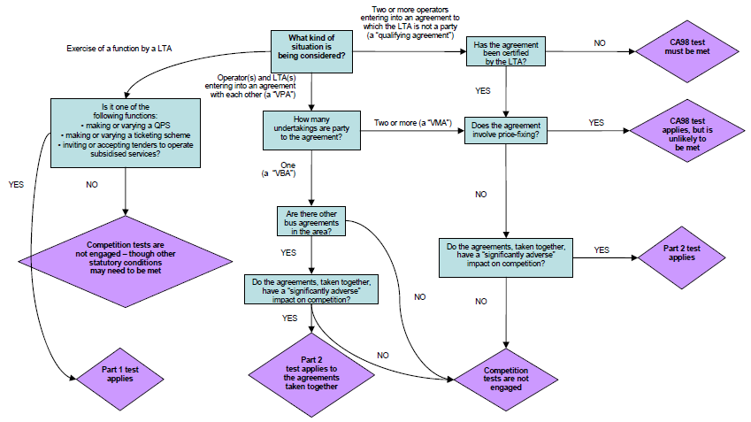
Query: Should we develop this local bus service partnership decision support tool into something more generic?
Source: http://www.dft.gov.uk/pgr/regional/localtransportbill/vpaguidance.pdf

Appendix 5 - Use of an independent third party or trustee
If under particular circumstances, where participants in a voluntary agreement/ standards organisation need to use sensitive individual figures (e.g. for the exchange of information or cost allocation) it is recommended to do so via an independent third party or trustee.
Who could be an independent third party?
A legal or natural person not directly or indirectly linked to a manufacturer/importer or their representatives. This independent third party may be for example an accountant, an auditor, a consultant, a law firm, a laboratory, a European/international organization, a neutral company, etc. The independent third party will not necessarily represent any participants but can be hired by them, for example to support certain activities. It is advisable that the independent third party signs a confidentiality agreement that will ensure that the independent third party undertakes not to disclose the information it receives.
The following activities can be facilitated by a independent third party for EC competition law purposes:
Produce aggregated anonymous figures
When participants need to refer to the aggregate of sensitive individual figures, the independent third party will request them to provide their individual input. The input will be collated and aggregated into a composite return that does not give the possibility of deducing individual figures (e.g. by ensuring that there will be a minimum of three participants). In addition, no joint discussion shall take place between this independent third party and the participants on the anonymous or aggregated figures. Questions should be addressed on an individual basis between each participant and the independent third party, who should not reveal any other data during such discussion.
Calculation of cost allocation based on individual figures for cost sharing
Where participants decide that all or part of their cost sharing should be based on their actual and individual figures (e.g. sales or production volumes), the independent third party will send a questionnaire to each of the individual participants to collect the relevant confidential individual information. It will then send to each participant an invoice corresponding to its particular amount only.
Companies need to send sensitive individual information to the authorities, without circulating it to the other actors
The independent third party would produce a non-confidential version of the same document for the remaining participants or the public that shall not contain sensitive information.
Based on ‘Cefic REACH competition law compliance guidance’, http://www.cefic.be/files/downloads/Cefic-REACH-guidance-DO-&-DON'T.pdf

Disclaimer
This publication is for informational purposes only, and to the extent that it is passed on, care must be taken to ensure that it is a form which accurately presents the information presented here. The information contained herein is of a general nature and is not intended to address the circumstances of any particular individual or entity.
No one should act on such information without appropriate professional advice after a thorough examination of the particular situation.
The information and opinions presented in this publication have been obtained from sources believed by the authors to be reliable, however, the author make no representation as to their accuracy or completeness and accept no liability for loss arising from the use of the material.
Although we endeavour to provide accurate and timely information, there can be no guarantee that such information is accurate as of the date it is received or that it will continue to be accurate in the future.

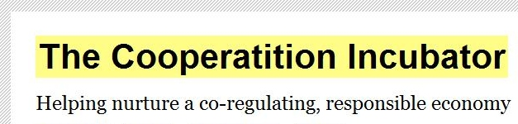
www.cooperatition.org

The Cooperatition Incubator is managed on a not-for-profit basis by Sensonido Ltd.
Reg. No. 3929456 Reg. office: 2 Upper Butts • Brentford • TW8 8DA • UK

http://www.bitc.org.uk/applications/dynamic/glossary.rm?id=19002&initial=C
http://www.bitc.org.uk/applications/dynamic/glossary.rm?id=19002&initial=S
See reports by the Better Regulation Task Force: ‘Imaginative regulation’ (2003) http://archive.cabinetoffice.gov.uk/brc/upload/assets/www.brc.gov.uk/imaginativeregulation.pdf; and ‘Alternatives to regulation’ (2004) http://archive.cabinetoffice.gov.uk/brc/upload/assets/www.brc.gov.uk/alternative.pdf
http://stakeholders.ofcom.org.uk/binaries/consultations/coregulation/statement/statement.pdf
The Governance Triangle © Kenneth Abbott (2008) Arizona State University **Ed - Draft simplified triangle and include terms in Glossary**
Héritier, Adrienne and Eckert, Sandra (2009) "Self-Regulation by Associations: Collective Action Problems in European Environmental Regulation," Business and Politics: Vol. 11 : Iss. 1, Article 3. http://www.bepress.com/bap/vol11/iss1/art3/
http://www.ethicalcorp.com/resources/downloads/20084163540_ECI%20-%20Conservative%20Party%20Working%20Group%20On%20Responsible%20Business.pdf
http://www.som.cranfield.ac.uk/som/dinamic-content/research/doughty/CollaborativeCommitments2FINAL.pdf
The term ‘Cooperatition’ is first cited by David Allen in ‘Competing Visions for World Telecommunications: The Global Evolution of Industry Structure’ in ‘The Race to European Eminence: Who Are the Coming Tele-Service Multinationals?’, Ove Grandstrand and Erik Bohlin, eds., North-Holland, Amsterdam (1994). Allen suggests the term was coined by MCI. http://www.davidallen.org/papers/Competing%20Visions.pdf
The term antitrust is used in place of competition in US law
Since the repeal of the Restrictive Trade Practices Act 1976 by the Competition Act 1998: “It is for businesses themselves to determine whether or not their agreements and/or conduct comply with competition law.” Source: Competing fairly – An introduction to the laws on anti-competitive behaviour (OFT, 2005) http://www.oft.gov.uk/shared_oft/business_leaflets/ca98_mini_guides/oft447.pdf
http://ec.europa.eu/competition/information/treaty.html
Treaty on the Functioning of the European Union (TFEU), http://eur-lex.europa.eu/LexUriServ/LexUriServ.do?uri=OJ:C:2008:115:0047:0199:EN:PDF
http://ec.europa.eu/competition/consultations/2010_horizontals/guidelines_en.pdf, p 79.
http://oft.gov.uk/shared_oft/economic_research/oft1059.pdf
‚Competition Law and Public Policy: Reconsidering an Uneasy Relationship. The Example of Art. 81’, http://cadmus.iue.it/dspace/bitstream/1814/7623/3/LAW-2007-30.pdf, pg. 19
Ibid., pg 10
http://oft.gov.uk/shared_oft/economic_research/oft1059.pdf
NMa (Netherlands Competition Authority) and ACCC (Australian Competition Authority) have considered issues surrounding self-/co-regulation and the public interest in depth. Also see section 2.4.4
http://stakeholders.ofcom.org.uk/binaries/consultations/coregulation/statement/statement.pdf
OFT guidance – 'Trade associations, professionals and self-regulatory bodies: understanding competition law' Dec 2004. OFT408.
http://www.decc.gov.uk/assets/decc/legislation/cc_act_08/key_docs/partial-ia-carrierbags.pdf
Now Article 101
http://eur-lex.europa.eu/LexUriServ/LexUriServ.do?uri=OJ:C:2001:003:0002:0030:EN:PDF
http://europa.eu/legislation_summaries/competition/firms/l26062_en.htm
http://ec.europa.eu/competition/consultations/2010_horizontals/guidelines_en.pdf
paragraph 277
‘An Assessment of the Public Benefit Test in Authorisation Determinations by the ACCC’ (2005) Vijaya Nagarajan http://cccp.anu.edu.au/projects/VijNagaraganPaperSept05PubBenefit.pdf
Ofer Green (July 2009) citing Antitrust File 4445/01 Supersol Ltd., et al. v. General Director of the Israel Antitrust Authority – unpublished
http://www.nmanet.nl/nederlands/home/jaarverslag_2009/files/NMa_Jaarverslag_2009_EN.pdf
Model Agreements for Consortia and other Forms of Data Sharing according to REACH Reg., http://reach.bdi.info/Rechtstexte/Introduction_REACH_Model_Agreement.pdf, http://guidance.echa.europa.eu/docs/guidance_document/data_sharing_en.pdf
Paragraph 311.
Based on CECED Commission decision - reference
http://www.cefic.be/files/downloads/Cefic-REACH-guidance-DO-&-DON'T.pdf
http://www.abhi.org.uk/multimedia/docs/home/abhi-cobp-december-2009.pdf , see Appendix 3
https://www.bimco.org/Corporate/Misc%20documents/BIMCO_Competition_Law.aspx
http://www.cefic.be/files/downloads/Cefic-REACH-guidance-DO-&-DON'T.pdf
http://www.wrap.org.uk/downloads/Round_Table_agenda_-_05_July_07.04d3c2f4.3917.pdf
http://www.schiphol.nl/web/file?uuid=6ef92be0-8cfe-45ef-a56b-1df4f661f199&owner=b77c9b24-31a1-48ce-89c6-4f8c6602ce99
http://www.wrap.org.uk/downloads/Seasonal_Pack_Red_Initiative_Legal_Compliance.1fc6e451.5280.pdf
http://www.cefic.be/files/downloads/Cefic-REACH-guidance-DO-&-DON'T.pdf
http://www.kcl.ac.uk/content/1/c6/03/40/61/KingsLecture2010AntitrustCompliance.pdf
http://www.sjberwin.com/Contents/Publications/pdf/49/b3d39860_e0c3_4ba2_9997_6372d4aab132.PDF
http://stakeholders.ofcom.org.uk/binaries/consultations/coregulation/statement/statement.pdf
http://www.gtz.de/de/dokumente/en-iseal-code-of-good-practice.pdf
http://www.isealalliance.org/content/codes-good-practice
http://www.isealalliance.org/sites/default/files/P005%20ISEAL%20Std-Setting%20Code%20v5.01%20Apr10.pdf
‘The competition impact of environmental product standards‘ (Frontier Economics report for the OFT, 2008) http://www.oft.gov.uk/shared_oft/economic_research/oft1030.pdf
Directive 2005/32/EC establishing a framework for the setting of ecodesign requirements for energy-using products, http://www.energy.eu/directives/l_19120050722en00290058.pdf
http://www.oft.gov.uk/shared_oft/economic_research/oft1059.pdf, see p. 47-49.
Other models to consider are the ISEAL Alliance Codes of Practice and ‘Models of self-regulation’ (National Consumers Council, 2000) http://www.talkingcure.co.uk/articles/ncc_models_self_regulation.pdf
http://www.oft.gov.uk/shared_oft/reports/consumer-policy/oft1115.pdf, pgs.21 and 22
Communication from the Commission to the Council, the European Parliament and the European Economic and Social Committee, ‘Contributing to Sustainable Development: The role of Fair Trade and non-governmental trade-related sustainability assurance schemes’, May 2009, http://trade.ec.europa.eu/doclib/docs/2009/june/tradoc_143373.pdf
http://www.ethicalclothingaustralia.org.au/business/how-it-works
http://www.accc.gov.au/content/index.phtml/itemId/718755/fromItemId/620299
http://www.wbcsdcement.org/index.php?option=com_content&task=view&id=174&Itemid=232
Ref
http://oft.gov.uk/shared_oft/economic_research/oft1059.pdf, pg 2
http://www.defra.gov.uk/foodfarm/food/pdf/food2030strategy.pdf, pg 8
Completing competition assessments in Impact Assessments, OFT, 2007 http://www.oft.gov.uk/shared_oft/reports/comp_policy/oft876.pdf
At present the OFT estimates conservatively that cartels that are established to the consumer detriment lead to a 10 percent overcharge. Source: ‘A Review of OFT's Impact Estimation Methods’, Professor Stephen Davies, January 2010, pg 24 http://www.oft.gov.uk/shared_oft/reports/Evaluating-OFTs-work/oft1164.pdf
http://www.berr.gov.uk/files/file45711.pdf
http://www.opsi.gov.uk/acts/acts1976/pdf/ukpga_19760034_en.pdf
http://www.oft.gov.uk/advice_and_resources/resource_base/approved-codes/
SI 2008 No. 1820
http://www.foe.co.uk/resource/briefings/voluntary_approach.pdf
http://www.iccwbo.org/uploadedFiles/ICC/policy/competition/Statements/Horizontal_Coop_Agmnts_Final_25_06_10.pdf http://www.iccwbo.org/uploadedFiles/ICC/policy/competition/Statements/Horizontal_Coop_Agmnts_Final_25_06_10.pdf
http://cooperatition.org/wp-content/uploads/2010/06/The-Cooperatition-Incubator-EU-Horizontal-Agreements-Guidelines-2010-consultation-response-June-2010-v1.1.pdf
http://cooperatition.org/2010/06/15/defra-to-develop-waste-responsibility-deals-says-spellman/
http://www.defra.gov.uk/evidence/economics/susdev/documents/esd-review-report.pdf
http://www.hm-treasury.gov.uk/d/green_book_complete.pdf
http://www.defra.gov.uk/corporate/policy/guidance/env-impact/index.htm
http://www.defra.gov.uk/environment/policy/natural-environ/using/valuation/index.htm
http://www.decc.gov.uk/assets/decc/legislation/cc_act_08/key_docs/partial-ia-carrierbags.pdf, pg. 2
http://www.wrap.org.uk/media_centre/press_releases/total_carrier_bag.html
http://resource-accounting.org.uk/
http://www.oneplaneteconomynetwork.org/resources/programme-documents/Scenario_Scoping_Report.pdf
http://cooperatition.org/2010/07/12/doh-sets-out-how-responsibility-deal-will-be-part-of-new-approach-to-public-health/
http://cooperatition.org/2010/01/31/does-fashion-sector-offer-opportunity-for-new-responsibility-deal/
http://www.defra.gov.uk/corporate/policy/guidance/sd-impact/index.htm
http://www.dh.gov.uk/en/Publicationsandstatistics/Legislation/Healthassessment/DH_4093617
http://www.justice.gov.uk/guidance/humanrights.htm
http://www.defra.gov.uk/sustainable/government/progress/documents/SDI2010_001.pdf
http://www.agilitylogistics.com/EN/GIL/Documents/Agility_PDF/CompliancePolicy.pdf
http://www.bba.net/bbaarchive/pdf/CompetitionComplianceJune2005.pdf
http://www.roche.com/behaviour_in_competition.pdf
http://www.costain-group.com/externaldocs/responsibility/CompetitionLawsCompliancePolicy080808.pdf
http://www.kcl.ac.uk/content/1/c6/03/40/61/KingsLecture2010AntitrustCompliance.pdf
http://www.isealalliance.org/content/standard-setting-code
http://www.isealalliance.org/content/impacts-code
http://www.isealalliance.org/content/verification-code

